Project 1 Title: Railway_Gauages
Scenario 1:
Basic Data Loading & Cleaning:
The mainly steps of working with a dataset using Pandas and data loading is the process of importing data from a file for analysis. When data is incomplete by cleaning the data .we make it for further analysis visualization.

1.Load the dataset into a Pandas DataFrame: Pandas provides functions like read_csv() to data load into a DataFrame and it easy to analyze data.
2. Display the first 5 rows and column names to understand structure: what your dataset looks like loading it into Pandas. It helps you understand the structure, columns, and values before doing any analysis.
3. Check for missing values and replace them with 0 : Missing values are replaced with 0 to avoid error .
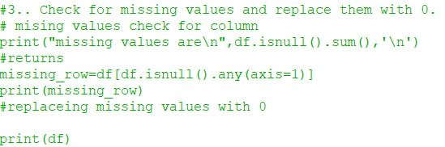

4. Convert all relevant gauge columns (Broad, Metre, Narrow, Total) to numeric types: Columns like Broad, Metre, Narrow, Total are converted to numbers so we can do run.
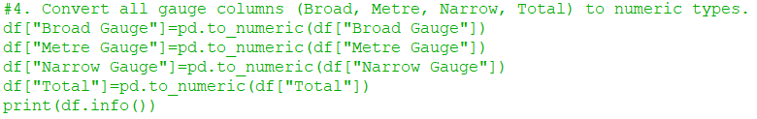

Conclusion:
Data cleaning is very important before analysis. It removes errors and makes data easy to run. After cleaning, the dataset becomes easy to use. This helps in getting correct results. Clean data gives better output.

Scenario 2:
Simple Visualization
we create a graph to understand data easily. We use Year and Total columns. A line graph helps us see how railway tracks change over time. Graphs make data simple and easy to understand.

- Extract the Year and Total columns: Select the data take only year and Total columns.
- Plot a line graph showing Total tracks over the Years: A line graph show the everytime changes.
- Add:
- Title
- X and Y labels

Title explain the graph
- x-axis=year
- y-axis=Total

- Identify whether the overall trend is increasing or decreasing: A line is too straight
When track is up its increasing and track is down its decreasing.

Conclusion: data makes easy to understand. A line graph clearly shows changes over time. It helps to find trends. This makes analysis simple.

Scenario 3:
Filtering + Bar chart
We knows to railway data We filter the dataset to after 2000 keep only recent years. Then we compare different railway gauges using a bar chart. A bar chart helps to multiple categories types. its easy to see which gauge is more used in recent years.

- Filter the dataset to include only years after 2000: Select the only years after 2000 to run the data.
2.Select the Broad Gauge, Metre Gauge, and Narrow Gauge columns :
Only used to selective column:
- Broad Gauge
- Metre Gauge
- Narrow Gauge
3.Plot a grouped bar chart comparing the three gauges : Compare the all three gauges each year has three bar.
4. Add a legend and ensure proper labels :
We add to :
- Xlabel
- Ylabel
- Legend

- Identify which gauge dominates in recent years: Dominating means the railway gauge that has the high value to other value.

Conclusion:
Mainly focus on recent data. The bar chart makes comparison with graph .we can show the which gauge is most used. This helps to railway development trends.

